Sequential Search

Question 1
Write a program to implement Sequential Search to find a given element in an array.
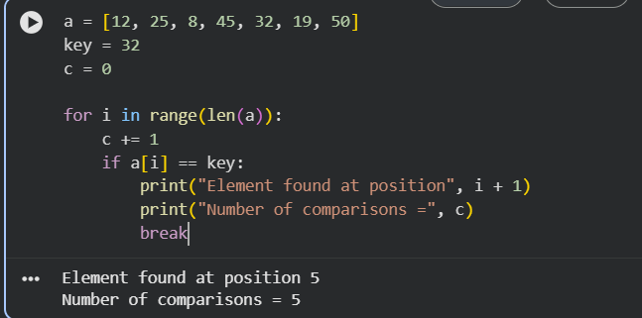
Question 2
Implement Sequential Search for an unsuccessful search.
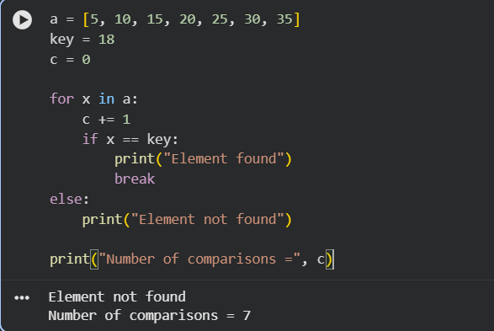
Question 3
Write a program to find the first occurrence of an element using Sequential Search.
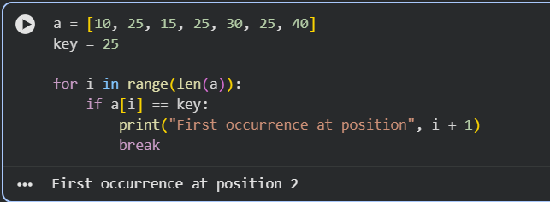
Question 4
Implement Sequential Search to find all occurrences of a given element.
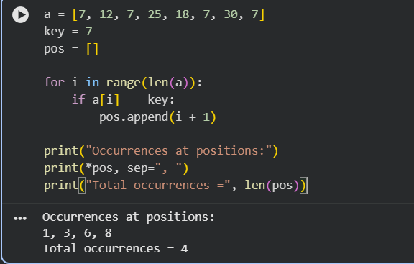

Question 5
Write a program to count:
● Total comparisons
● Total matches
● Total mismatches
during Sequential Search.
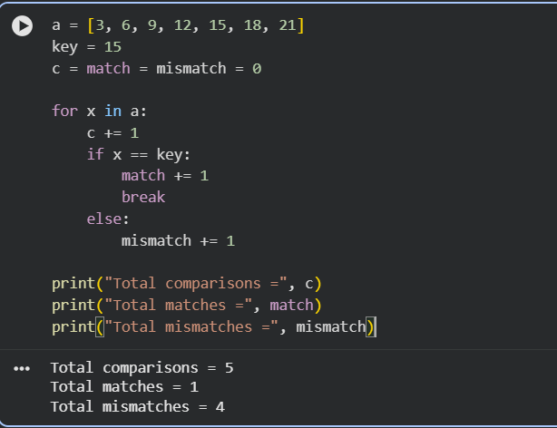

Question 6
Implement Sentinel Sequential Search and compare it with ordinary Sequential Search
.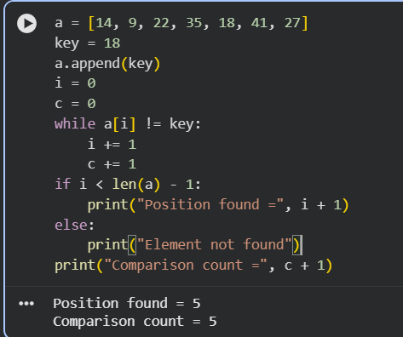
Question 7
Write a program to perform Sequential Search on an array of student register numbers.
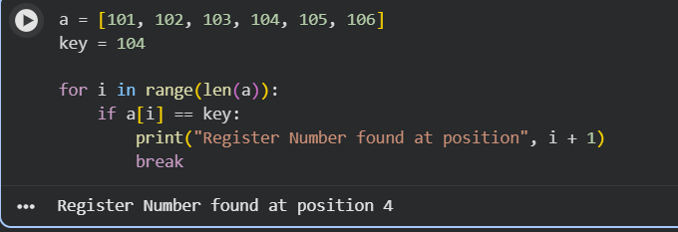

Question 8
Implement Sequential Search for string data.
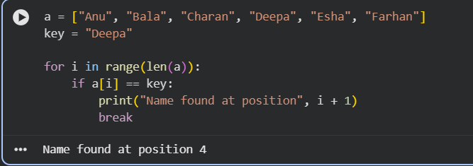 Question 9
Write a program to perform Sequential Search on a 2-D matrix.
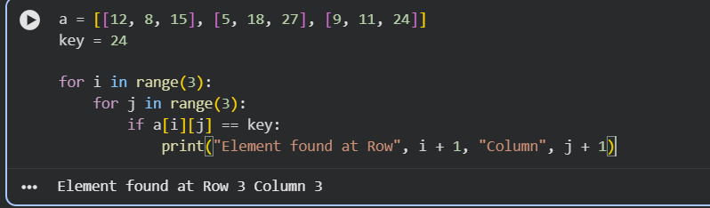
Question 10
Implement Sequential Search and analyze its performance.
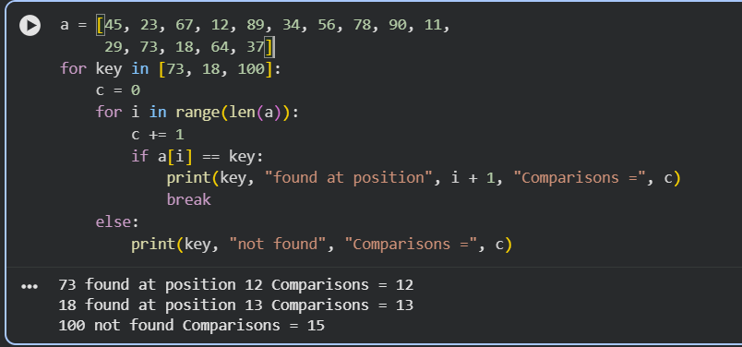

Brute Force String Matching

Question 1
Implement the Brute Force String Matching Algorithm to search for a pattern in a given text.
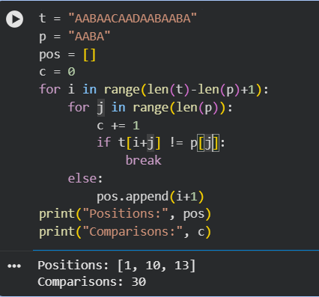
Question 2
Write a program to find all occurrences of a pattern in a text using Brute Force String Matching.
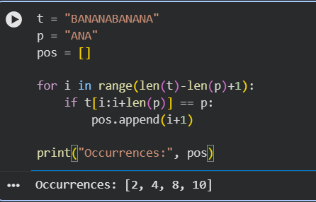
Question 3
Implement Brute Force String Matching and display the comparison table for each alignment.
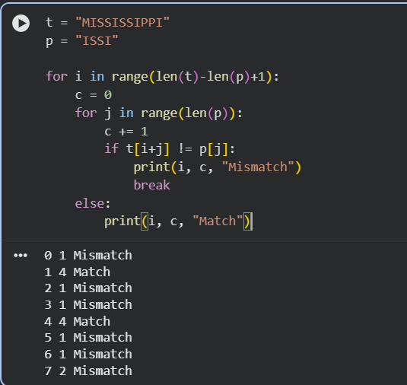
Question 4
Write a program to count:
● Total character comparisons
● Total matches
● Total mismatches
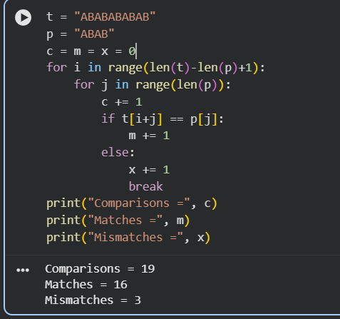
Question 5
Implement Brute Force String Matching and determine whether the search is:
● Best Case
● Average Case
● Worst Case
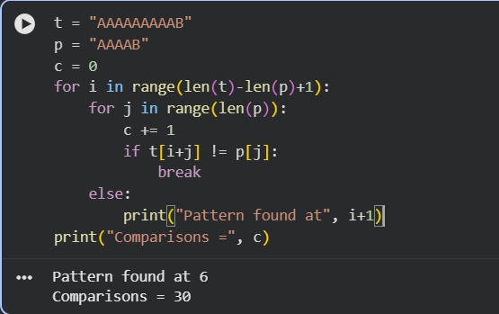
Question 6
Write a program that searches for a pattern in a text and reports the first occurrence only using
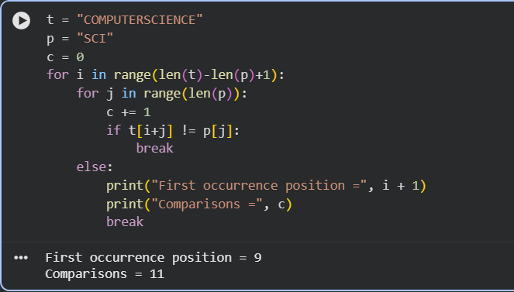
Question 7
Implement Brute Force String Matching for case-insensitive searching.
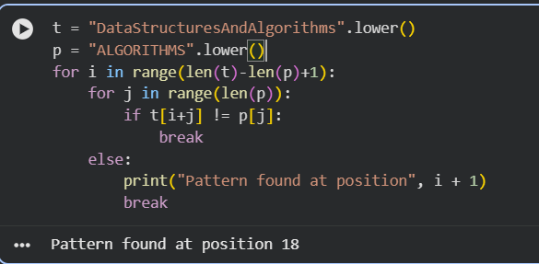
Question 8
Write a program to compare the execution of Brute Force String Matching for:
1. Successful search
2. Unsuccessful search
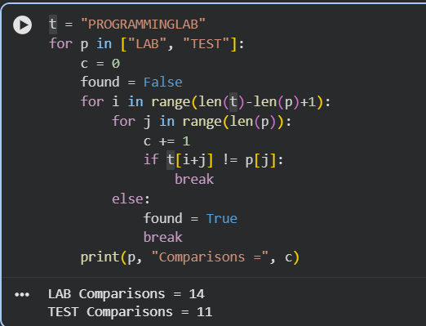
Question 9
Implement Brute Force String Matching and display every alignment of the pattern with the text.
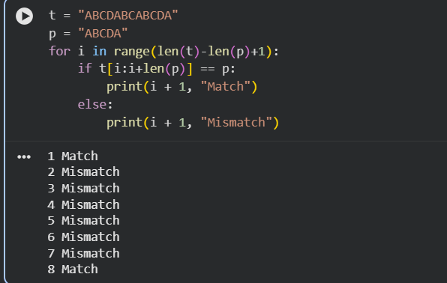
Question 10
Write a complete program for Brute Force String Matching and perform complexity analysis.
